# 2020 Census EA Framework Selection and Customization

Scope: The Census Bureau is an agency of the Commerce Department

The initial list of possible EA Framework selections could be:

1. The Zachman Framework
2. Federal Enterprise Architecture Framework (FEAF)
3. The Open Group Architecture Framework (TOGAF)

**Considerations:**

The Zachman Framework handles large scale complexity potentially better than the FEAF and TOGAF frameworks.

But the Census Bureau Enterprise Architecture scope is only for the individual agency.

So the Zachman Framework may be overkill and not the best fit.

The FEAF and TOGAF are the remaining frameworks being considered now.

TOGAF might be a simpler lighter weight framework with customization that would be a best fit than FEAF.

We determined TOGAF with customization offers the least complexity requirements for the 2020 Census Bureau Enterprise Architecture and Infrastructure Transition Plan.

Rationale: TOGAF is simpler to adopt, adapt, and customize and tailor to the needs of a single government agency.

The 2020 Census architecture is described in the context of the seven domains as shown in Figure 5-1.

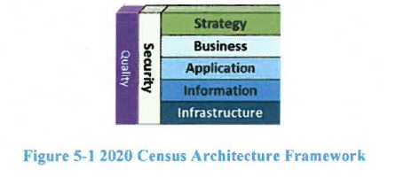

**2020 Census EA Framework Customization**

The **Strategy Domain** consists of the program vision and mission level business requirements.

The **Business Domain** describes business goals and business operations.

The **Application Domain** describes the application areas and their respective systems and services.

The **Information Domain** describes the enterprise information and data dictionary.

The **Infrastructure Domain** describes the supporting segments and operations.

The **Security Domain** describes the security features and mechanisms throughout all of the other domain areas.

The **Quality Domain** describes the support for scalability, reliability, and performance dimensions.